<https://helpline.wipro.com/>

First time may ask to fill below details, you can select any location, sublocation, tower, floor, Wing, ODC and your mobile number and Cubicle number mention NA.

Once the office resumed back you can update exact details.

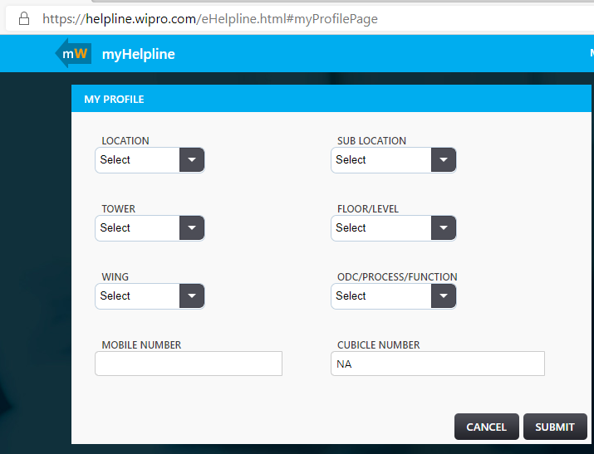

Write ticket description and submit

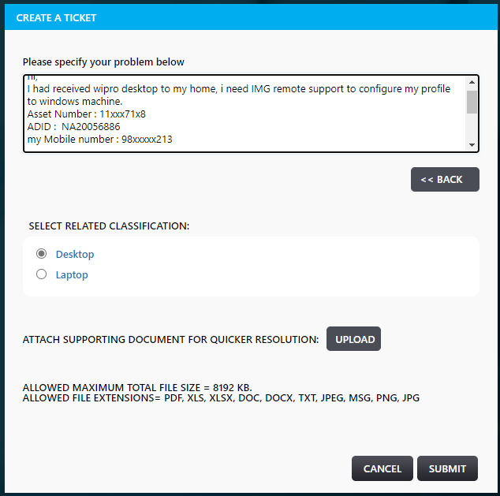

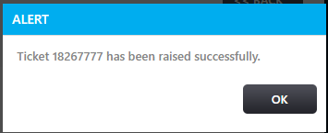

Then write a mail to Service Desk and mention ticket number in mail subject.

Service Desk mail-ids: [mention all these mail-ids in recipient]

asish.agarwala@wipro.com

bhaskar.bv4@wipro.com

dipshila.mridha@wipro.com

juhi.justin@wipro.com

mithun.das@wipro.com

mohit.kumar49@wipro.com

nidhi.raj6@wipro.com

pavithra.m11@wipro.com

prashant.singh8@wipro.com

ranjeet.pandey@wipro.com

sanu.singh@wipro.com

siddharth.bajetha@wipro.com

sribally.mohanty@wipro.com

susanta.behera3@wipro.com

venkatesh.kumar13@wipro.com

zeeshan.iqubal@wipro.com